

STUDENT: NAME KELVIN MEIN
REG NO: BSCCS/2024/56078
PROJECT TITLE: SECURE FILE ENCRYPTION SYSTEM
SELECTED TECHNOLOGIES:
- Python+SQLite
- OpenSSL
- Kali linux security tools

WEEK 8 PUBLIC KEY INFRASTRUCTURE AND DIGITAL CERTIFICATES 3
1.1 CLASS EXERCISE ONE UNDERSTANDING ASYMETRIC CRYPTOGRAPHY 3
Table 2: Symmetric vs Asymmetric Encryption 4
1.2 CLASS EXERCISE TWO COMPLEXITY AND CRYPTOGRAPHY 5
PRACTICAL TASK : IMPLIMENTING DIFFIE-HELLMAN KEY EXCHANGE 6
Fig one : Diffie-hellman key exchange 6
1.3Assignment 7

WEEK 8 PUBLIC KEY INFRASTRUCTURE AND DIGITAL CERTIFICATES

CLASS EXERCISE ONE UNDERSTANDING ASYMETRIC CRYPTOGRAPHY
Explain the difference between Public key and private key also Symmetric encryption and assymetric encryption

Table 1: Public Key vs Private Key
Feature | Public Key | Private Key
Who can see it | Anyone , shared openly | Only the owner , kept secret
Used to | Encrypt messages / verify signatures | Decrypt messages / create signatures
Analogy | A padlock anyone can snap shut | The key that unlocks the padlock
Derived from | Generated from the private key (mathematically) | Generated randomly — never derived
If compromised | No problem, it is public by design | Everything is broken rotate immediately

Table 2: Symmetric vs Asymmetric Encryption
Feature | Symmetric Encryption | Asymmetric Encryption
Keys used | One shared secret key | Two keys: public and private pair
How it works | Same key encrypts and decrypts | Public key encrypts; private key decrypts
Speed | Very fast and great for large data | Slower as it is computationally heavy
Key sharing problem | There is securely sharing the key is tricky | No public key can be sent openly
Examples | AES-256, DES, 3DES | RSA-2048, ECC, Diffie-Hellman
Best used for | Encrypting bulk data (files, disks) | Secure key exchange, digital signatures
Real-world use | HTTPS data transfer (after handshake) | HTTPS handshake, SSH, email (PGP)

1.2 CLASS EXERCISE TWO COMPLEXITY AND CRYPTOGRAPHY
Discuss why computationally hard problems are important in modern cryptographic systems.
Provide at least three examples.
Computationally hard problems are important in cryptography because they make it extremely difficult for attackers to break encryption or recover secret keys, ensuring secure communication and data protection.
Examples:
- Integer Factorization – Used in RSA encryption.
- Discrete Logarithm Problem – Used in Diffie–Hellman key exchange and Digital Signature Algorithm.
- Elliptic Curve Discrete Logarithm Problem (ECDLP) – Used in Elliptic Curve Cryptography for secure and efficient encryption.

PRACTICAL TASK : IMPLIMENTING DIFFIE-HELLMAN KEY EXCHANGE

Fig one : Diffie-hellman key exchange
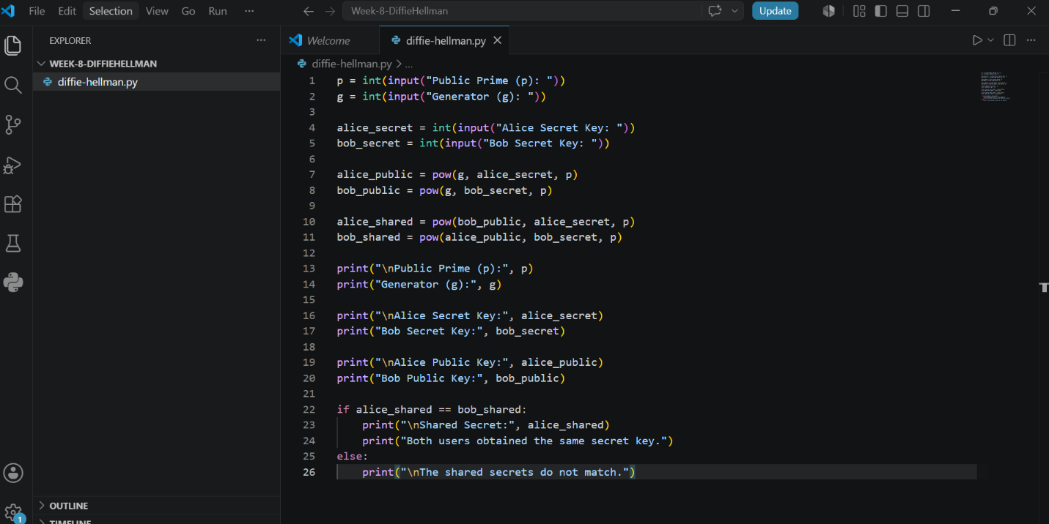

OUTPUT
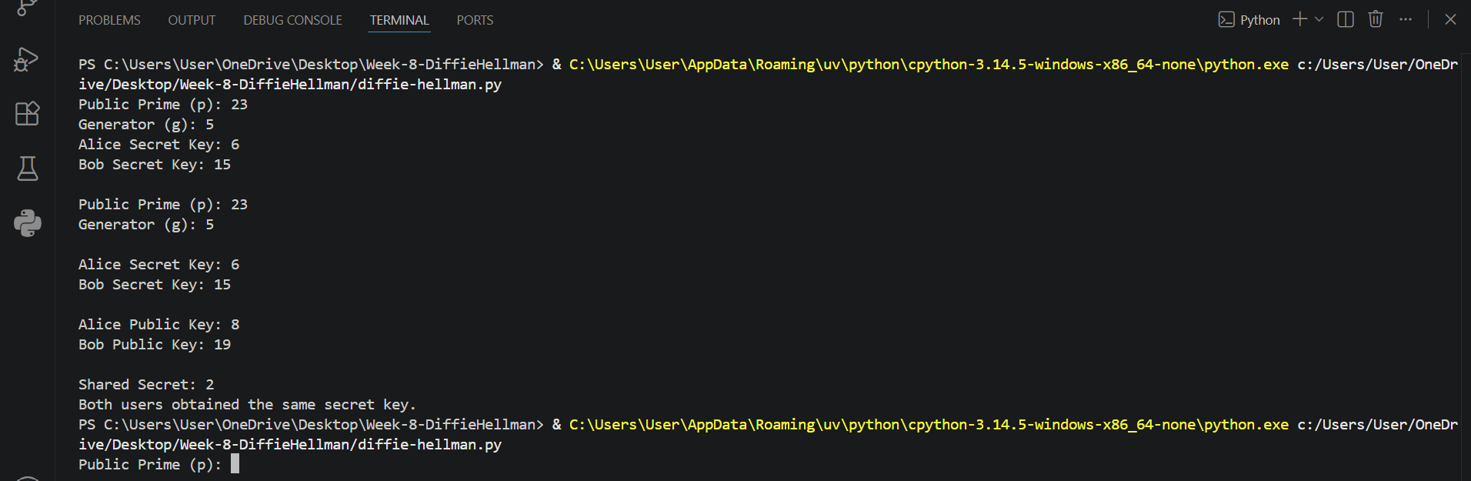

1.3Assignment
Research and write a report on the role of the Diffie-Hellman Key Exchange in modern Internet security.

1. Definition of Diffie-Hellman Key Exchange
The Diffie-Hellman (DH) Key Exchange is a cryptographic protocol that enables two parties to securely establish a shared secret key over a public, untrusted channel without ever transmitting the secret itself. Published in 1976 by Whitfield Diffie and Martin Hellman in their paper "New Directions in Cryptography," it is one of the most significant contributions to modern cryptography. DH is not an encryption algorithm; it is a key agreement protocol whose output the shared secret is then used as a key for symmetric encryption algorithms such as AES. By eliminating the need for a pre-shared secret, DH made secure communication over open networks like the Internet practically achievable.
2. How the Protocol Works
DH is based on modular arithmetic. Both parties , Alice and Bob ,first agree on two public values: a large prime number p and a generator g (where g < p). Alice then picks a private integer a and computes her public value A = g^a mod p. Bob picks a private integer b and computes B = g^b mod p. They exchange A and B over the insecure channel. Alice computes the shared secret as S = B^a mod p, and Bob computes S = A^b mod p. Because of modular exponentiation properties, both arrive at the same value: S = g^(ab) mod p. An eavesdropper who intercepts g, p, A, and B cannot feasibly compute S without knowing a or b and deriving those from the public values is the Discrete Logarithm Problem, described in the next section.
3. The Discrete Logarithm Problem
The security of DH rests entirely on the hardness of the Discrete Logarithm Problem (DLP): given g, p, and A = g^a mod p, find a. For small numbers this is trivial, but when p is a 2,048-bit prime or larger, no classical algorithm can solve it in a practical timeframe. The best known attack the General Number Field Sieve still requires exponential effort relative to key size. It is important to note that DLP is considered computationally hard, not mathematically proven unsolvable; a future efficient algorithm would immediately break DH security. A related variant, Elliptic Curve Diffie-Hellman (ECDH), applies the same concept to elliptic curves, where the analogous problem is believed to be harder still allowing equivalent security with far smaller keys (e.g., 256-bit ECDH ≈ 3,072-bit classical DH).
4. Applications in TLS/SSL
Transport Layer Security (TLS) and its predecessor SSL secure every HTTPS connection web browsing, banking, email, and more. During a TLS handshake, client and server must agree on a session key before any encrypted data flows. Earlier TLS versions relied on RSA for key exchange, which lacks forward secrecy: if the server's private key is ever stolen, all past recorded sessions can be decrypted. TLS 1.2 addressed this by introducing Ephemeral Diffie-Hellman (DHE) and Ephemeral ECDH (ECDHE) cipher suites. In these modes, fresh DH key pairs are generated per session and immediately discarded, providing Perfect Forward Secrecy (PFS) past sessions remain secure even if long-term keys are later compromised. TLS 1.3 (RFC 8446, 2018) went further by removing all non-forward-secret key exchange methods entirely, mandating ECDHE as the baseline. This makes DH-based key exchange not merely optional but a fundamental requirement of modern TLS.
5. Security Challenges and Possible Solutions
5.1 Weak Parameters Logjam Attack
In 2015, the Logjam vulnerability revealed that many servers still accepted 512-bit DH parameters, originally weakened by Cold War-era US export regulations. Attackers could downgrade TLS connections to these parameters and break the key exchange offline. The fix is to enforce a minimum of 2,048-bit DH parameters and prefer ECDHE with vetted curves such as Curve25519.
5.2 Man-in-the-Middle Attacks
DH alone provides no authentication. Without verifying the other party's identity, an attacker can silently intercept and replace both sides' public values. TLS addresses this by pairing DH key exchange with X.509 digital certificates signed by a trusted Certificate Authority (CA), ensuring the server's identity is confirmed before the shared secret is used.
5.3 Quantum Computing Threat
The most serious long-term threat to DH is quantum computing. Shor's algorithm can solve the Discrete Logarithm Problem in polynomial time on a sufficiently powerful quantum computer, rendering both DH and ECDH completely insecure. While no such machine exists today, NIST finalised its first post-quantum cryptography standards in 2024 including ML-KEM (Kyber) for key encapsulation and the industry is actively planning a managed transition away from DH-based systems.
Conclusion
The Diffie-Hellman Key Exchange remains one of the most consequential inventions in cryptographic history. By solving the key distribution problem through modular arithmetic, it made secure communication over public networks possible and continues to underpin billions of TLS connections daily through its ephemeral variants. However, weak parameter selection, authentication gaps, and the approaching quantum computing era all demand continued vigilance. The cryptographic community's shift toward post-quantum alternatives is underway, but DH's influence on modern Internet security and the lessons its vulnerabilities have taught will remain relevant for decades to come.
References
- Diffie, W., & Hellman, M. E. (1976). New directions in cryptography. IEEE Transactions on Information Theory, 22(6), 644–654.
- Adrian, D., et al. (2015). Imperfect forward secrecy: How Diffie-Hellman fails in practice. Proceedings of the 22nd ACM CCS.
- Rescorla, E. (2018). The Transport Layer Security (TLS) Protocol Version 1.3. RFC 8446. IETF.
- National Institute of Standards and Technology. (2024). Post-Quantum Cryptography Standards. NIST IR 8413.
- Stallings, W. (2022). Cryptography and Network Security: Principles and Practice (8th ed.). Pearson.

